**RISK MANAGEMENT PLAN OF "REMEDIES" POSTPARTUM CARE CENTER: FRAMEWORK FOR MITIGATING CHALLENGES AND ENHANCING QUALITY**

**Irhamdani1, Rhian Indradewa2, Unggul Kustiawan3, Rian Adi Pamungkas4**

Universitas Esa Unggul, Indonesia

Email: [irhamdani.rasyied@gmail.com](mailto:irhamdani.rasyied@gmail.com)1*, [rhian.indradewa@esaunggul.ac.id](mailto:rhian.indradewa@esaunggul.ac.id)2, [unggul.kustiawan@esaunggul.ac.id](mailto:unggul.kustiawan@esaunggul.ac.id)3, [rian.adi@esaunggul.ac.id](mailto:rian.adi@esaunggul.ac.id)4

|  |  |
| --- | --- |
| **INFO ARTICLE** | **ABSTRACT** |
| **Keywords:** Risk Management, ISO 31000, Postpartum, Quality of Service, Risk Mitigation, Healthcare Center. | Risk management is a critical component of business operations, particularly in the healthcare sector, such as in postpartum care centers. This study aims to design a comprehensive risk management plan for Remedies, a postpartum care center in Indonesia, based on the ISO 31000:2018 standard. The proposed framework encompasses the identification, analysis, evaluation, and treatment of both internal and external risks that could impact service quality, reputation, and financial stability. Short-term, medium-term, and long-term objectives are formulated to ensure alignment with the company’s vision of becoming an innovative and inspirational care center.  The methodology employed involves risk analysis based on probability and impact, as well as the implementation of mitigation strategies tailored to Remedies' operational context. The findings reveal that the primary risks faced include clinical, reputational, compliance, operational, and financial risks. Risk treatment strategies focus on enhancing service quality, staff training, revenue diversification, and the adoption of innovative technologies. Additionally, communication and consultation with stakeholders are identified as crucial factors in ensuring the effectiveness of risk management.  This study provides practical contributions by offering a risk management framework that can be adapted by other healthcare centers. The recommendations emphasize the importance of regular monitoring, continuous evaluation, and adequate budget allocation for risk management implementation. By adopting these measures, Remedies can mitigate operational challenges, improve service quality, and achieve long-term financial stability |
|  |

**INTRODUCTION**

Risk management is a critical aspect of business operations, aimed at identifying, assessing, and managing risks that may affect the achievement of organizational objectives (Ahmed, 2025; Yuwono & Ellitan, 2025; Żurawski et al., 2025). In the context of the healthcare industry, such as that operated by Remedies, risk management becomes increasingly important due to the complexity of operations and the high demands for service quality (Mendes & França, 2025). Companies operating in postpartum care, like Remedies, must be able to manage both internal and external risks that could impact reputation, regulatory compliance, and financial sustainability (Martianto et al., 2025). Therefore, the implementation of a comprehensive risk management framework, such as ISO 31000:2018, is key to ensuring that the company can effectively respond to changes in the business environment (Saputra et al., 2021).

Risks in the healthcare business are not limited to clinical aspects but also encompass operational, financial, and reputational risks. For instance, clinical risks such as procedural errors or infections can directly impact patient health and the company’s reputation (Arami & Mulasari, 2021). Meanwhile, operational risks such as equipment failure or supply chain disruptions can hinder service delivery (Pranoto & Indradewa, 2023). Additionally, financial risks such as revenue fluctuations and rising operational costs must be managed effectively to ensure the company’s financial stability. Thus, risk management not only focuses on mitigating threats but also on transforming risks into opportunities to enhance organizational performance .

Effective risk management implementation requires a structured and integrated approach. ISO 31000:2018 emphasizes the importance of principles such as integration, inclusiveness, and continuous improvement in the risk management process (Hutchins, 2018). These principles ensure that risk management is not solely the responsibility of top management but involves all levels of the organization, including operational staff and external stakeholders such as suppliers and healthcare partners. By engaging various stakeholders, the company can identify risks more comprehensively and design more effective mitigation strategies.

Previous studies have demonstrated that effective risk management can enhance business resilience and support the achievement of strategic organizational goals. For example, research by (Zekos & Zekos, 2021) shows that proper risk identification and mitigation can reduce the negative impacts of changes in the business environment, such as market fluctuations and regulatory shifts. Furthermore, research (Parra et al., 2025) confirms that integrating risk management into daily business processes can improve operational efficiency and customer satisfaction (Chandrasekharan & Baser, 2025; Scavarda et al., 2025). Therefore, in the context of Remedies, the implementation of ISO 31000:2018-based risk management is expected to help the company achieve its vision of becoming an innovative and inspirational postpartum care center in Indonesia.

**RESEARCH METHODS**

This study employs a qualitative approach, focusing on the implementation of risk management based on the ISO 31000:2018 standard. The risk management process is carried out through several stages: establishing the scope, context, and criteria; risk assessment; risk treatment; communication and consultation; and monitoring and review. The first stage involves defining the scope and context of risks relevant to the company’s business objectives (Iman et al., 2022). Internal and external contexts are analyzed to identify factors influencing risks, such as the business environment, regulations, and market conditions. Risk criteria are established based on the likelihood and potential impact of risks, which are then used as a basis for decision-making (Larasati et al., 2020).

The second stage is risk assessment, which includes risk identification, analysis, and evaluation. Risk identification is conducted through internal experience, consultations with experts, and external analysis. Risk analysis involves determining the likelihood of risks occurring and their potential impact, enabling the prioritization of the most critical risks. Risk evaluation is carried out by creating an inherent risk map that illustrates the level of risk before mitigation measures are implemented. This stage is crucial for determining effective risk treatment strategies.

**RESULTS AND DISCUSSION**

Risk management planning is an essential part of business activities and an integral component of a company's operations. At Remedies, the goal is to minimize potential internal and external risks that could affect the company.

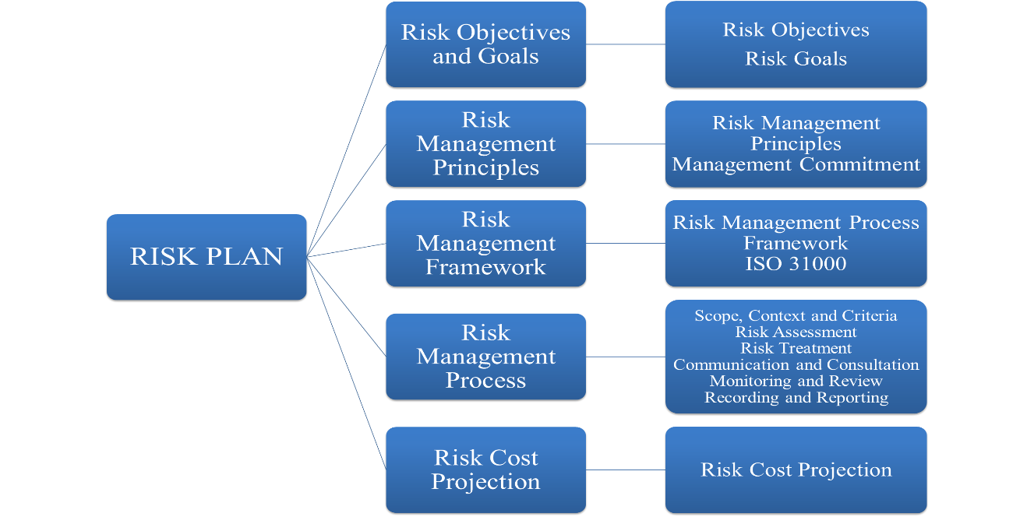

**Figure 1. Risk Management Framework for Remedies**

**Risk Objectives and Goals**

The objective of risk management at Remedies is to support the achievement of the company’s vision, which is to become an innovative and inspirational postpartum care center in Indonesia. Meanwhile, the risk management goals must align with the company’s overall objectives (Erisha et al., 2021). Remedies will adhere to the ISO 31000:2018 standard related to risk management. The specific objectives and goals of Remedies' risk management are outlined in the following table.

**Table 1.** *Risk Management Objectives and Goals*

| **Objective** | **Goals** |
| --- | --- |
| **Short-Term (0-1 Year)** | |
| Enhance company reputation | * Respond to 90% of negative reviews within 24 hours * Increase average review rating to 4.5 |
| Ensure business compliance with applicable regulations | * Conduct internal audits twice a year * Provide socialization and training on new regulations to staff |
| Ensure human resource quality and competence | * HR qualifications aligned with job competencies * Availability of HR competency development programs |
| Stabilize revenue amid patient volume fluctuations | * Increase the number of regular patients by 5% through promotional pricing * Increase revenue from additional services by 10% |
| **Medium-Term (1-3 Years)** | |
| Increase patient loyalty and satisfaction | * Achieve an average review rating of 4.7 out of 5 * Increase patient retention rate by 15% through loyalty programs * Conduct annual patient satisfaction surveys for service improvement |
| Ensure operational quality and efficiency | * Implement preventive maintenance systems to reduce equipment downtime by 20% * Reduce repair response time from 48 hours to 24 hours * Achieve service quality standards through routine inspections at least twice a year |
| Improve staff retention and competency development | * Reduce turnover by 30% through job satisfaction programs * Provide skills training for 80% of staff annually * Develop internal mentoring programs for new staff |
| Increase revenue and cost efficiency sustainably | * Increase revenue from additional services by 25% * Reduce operational costs by 15% through more efficient management * Allocate emergency funds equivalent to 10% of total annual revenue for financial stability |
| **Long-Term (>3 Years)** | |
| Build a trusted brand and increase market share | * Consistently achieve an average review rating of 4.8 out of 5 * Increase market share by 30% through marketing strategies * Establish partnerships with at least 10 health organizations/communities to expand reach |
| Become an efficient and innovative healthcare center | * Implement automation technology to reduce operational costs by 25% * Increase patient satisfaction in operational services to 90% * Adopt ISO or other international quality management standards |
| Create a professional, qualified, and loyal team | * Reduce turnover to below 10% * Increase staff job satisfaction to 85% * Ensure 100% of staff participate in annual skills development programs |
| Enhance financial stability and profitability sustainably | * Increase annual revenue by 40% through service diversification * Reduce operational costs by 20% through better asset management * Achieve a minimum profitability ratio of 15% and maintain a reserve fund equivalent to 15% of total annual revenue |

**Risk Management Principles**

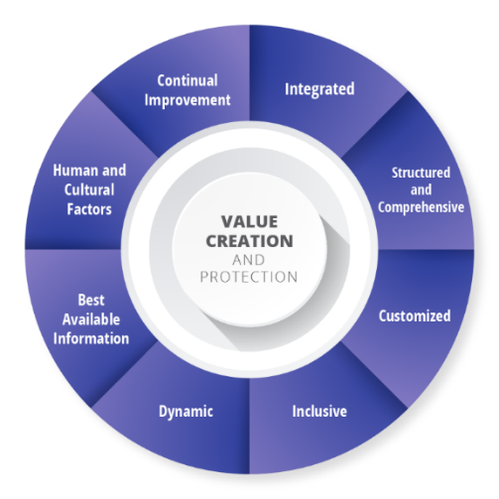The application of risk management principles based on ISO 31000:2018 must be relevant to the needs and challenges faced by Remedies. Below is a more specific explanation of the application of these principles:

**Figure 2. ISO 31000:2018 Risk Management Principles**

**Table 2.** ISO 31000 Risk Principles

|  |  |
| --- | --- |
| **Principle** | **Description** |
| Integrated | Risk management is integrated into all aspects of Remedies business, including patient care plans, daily operations, and strategic decision-making. |
| Structured and Comprehensive | Remedies approach to risk must be holistic, addressing everything from clinical risks (e.g., infections or postpartum complications) to operational risks (e.g., equipment failure or supply disruptions). |
| Customized | Remedies has its own unique challenges and needs. Risk management must be tailored to reflect the specific environment, patient demographics, and available resources and capabilities. |
| Inclusive | Involve staff at all levels, patients, and possibly third parties (e.g., suppliers or health partners) in the risk management process. This supports broader risk identification and more innovative solutions, ensuring all voices are heard and considered. |
| Dynamic | Risk management must be responsive to changes in internal conditions (e.g., procedural or staff changes) and external factors (e.g., pandemics or regulatory changes). |
| Best Available Information | Remedies decision-making must be based on the most current and accurate information, including clinical data, industry trends, and patient feedback. |
| Human and Cultural Factors | Recognize the importance of behavior, attitudes, and culture in risk management. |
| Continual Improvement | Risk management is not a one-time activity but an ongoing process. Remedies must regularly improve and refine its risk management practices to achieve continuous improvement in service quality and safety. |

**Risk Management Framework**

The risk management framework at Remedies relies heavily on the support and participation of various stakeholders for effective risk management. The primary goal of this framework is to ensure the integration of risk management into the core activities and critical functions of the business. There are six key aspects to the risk management framework, as illustrated below:

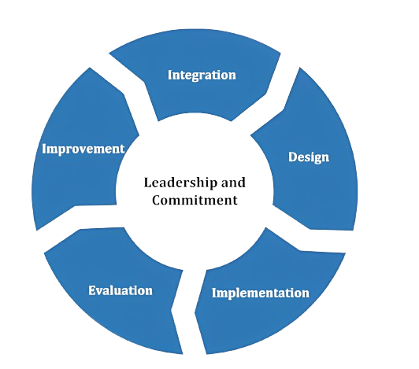

**Figure 3. ISO 31000:2018 Risk Management Framework**

**Risk Management Process**

The risk management process at Remedies aligns with the ISO 31000:2018 structure, as shown in the figure below:

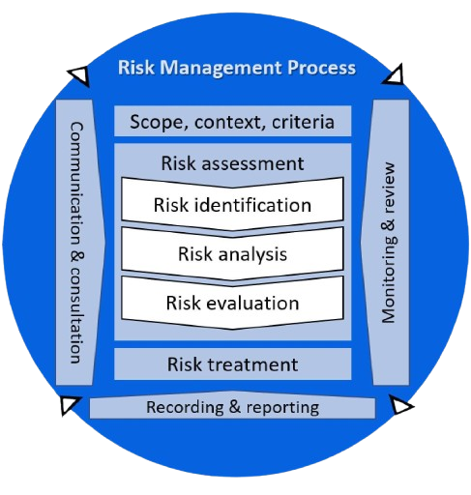

**Figure 4. ISO 31000:2018 Risk Management Process**

**Scope, Context, and Criteria**

In Remedies risk management, it is necessary to define the scope of risks early in the risk management process, focusing on the achievement of objectives. The process, from identification to assessment, is conducted with consideration of internal and external contexts, allowing threats and weaknesses to be transformed into opportunities in line with the ISO 31000:2018 risk management principles.

**Table 3.** Risk Probability Criteria

|  |  |  |  |  |  |  |  |
| --- | --- | --- | --- | --- | --- | --- | --- |
| **Risk Evaluation Matrix** | | | **Impact Level** | | | | |
| **1** | **2** | **3** | **4** | **5** |
| Very Low | Low | Medium | High | Very High |
| **Possibility Level** | 5 | Almost Definitely | 5 | 10 | 15 | 20 | 25 |
| 4 | Likely | 4 | 8 | 12 | 16 | 20 |
| 3 | Possible | 3 | 6 | 9 | 12 | 15 |
| 2 | Rare | 2 | 4 | 6 | 8 | 10 |
| 1 | Very Rare | 1 | 2 | 3 | 4 | 5 |

|  |  |  |
| --- | --- | --- |
| **Level Risk** | **Amount of Risk** | **Color** |
| Very High | 13 - 25 | Red |
| High | 10 - 12 | Orange |
| Medium | 5 - 9 | Yellow |
| Low | 3 - 4 | Green |
| Very Low | 1 - 2 | Blue |

Risk impact refers to the potential losses that may arise if a risk occurs. Risk impact is measured using an impact tolerance table, which includes quantitative and qualitative risk impacts expressed in descriptive assessments. Quantitative risk impact is measured in monetary terms, while qualitative risk impact is measured through descriptive evaluations. Qualitative risk analysis relies on experience, logic, and sound judgment to determine risk consequences and events. Meanwhile, quantitative risk analysis involves the use of numerical data to understand the likelihood and potential impact of a risk (Ramadhan et al., 2024).

**Risk Assessment**

Risk assessment is a fundamental process in risk management that helps a company like Remedies understand the risks it faces and the impact of each risk. This process involves identifying, analyzing, and evaluating risks to ensure that the company can make informed decisions about how to manage them.

**Risk Identification**

By accurately identifying and assessing risks, Remedies can manage risks more effectively. Below is the risk identification and impact assessment, as outlined in the following table.

**Table 4.** Risk Identification



**Risk Analysis**

Risk analysis is conducted by assessing the likelihood and impact of risks. Risk analysis determines how likely a risk is to occur and what its consequences would be. Below is the risk analysis for Remedies:

**Table 5.**Risk Analysis



Based on the risk analysis results, the risk assessment process includes evaluating risks based on the likelihood level, considering factors such as cost, time, and business process scope. Additionally, the impact level is assessed based on how frequently the risk may occur. The results of the risk analysis provide likelihood and impact scores, which serve as indicators for determining the risk level during the risk evaluation stage.

**Risk Evaluation**

After risk analysis, the next step is risk evaluation, which involves creating an inherent risk map. The inherent risk map is used to determine the level of identified risks and compare them with established risk criteria. This process involves assessing the likelihood and impact of risks, which are then used to determine the risk score and risk level. Risk evaluation is crucial for understanding the level of risk faced and planning appropriate risk treatment measures.

**Table 6.** Inherent Risk Map



Notes: - - - - - (risk appetite is the amount of risk you are willing to take)

The results of the risk evaluation show that risk assessment is based on the risk score obtained by multiplying the likelihood level and the impact level. Risk ranking is determined by ordering the risk scores from highest to lowest.

**Risk Treatment**

After risk treatment is applied, risk controls are modified. Risk treatment involves assessing and deciding whether the risk level is tolerable. If not, new risk treatments are developed, and the effectiveness of the treatment is reassessed. After risks are treated, they undergo changes. The next step is to implement risk treatment. After risks are treated, Remedies' risks change as follows:

**Table 7.** Risk Mitigation Map



Source: Author Team (2024)

**Communication and Consultation**

According to ISO 31000, communication and consultation are essential components of an effective risk management process. These activities include:

1. Engaging stakeholders in the risk management process to ensure their perspectives are valued and considered.
2. Building a shared understanding of the basis and rationale for risk management decisions and their consequences.
3. Providing and exchanging information related to risks and risk management between decision-makers and other stakeholders.
4. Encouraging and facilitating two-way feedback to ensure all perspectives and knowledge about risks are accommodated.
5. Ensuring transparency in the risk management process, allowing stakeholders to understand how decisions are made.

**Monitoring and Review**

In ISO 31000, monitoring and review are critical components of an effective risk management process. These activities include:

1. Regularly monitoring and measuring the performance of the risk management process, including the effectiveness of implemented control measures.
2. Periodically reviewing the risk management cycle to ensure it remains relevant, effective, and aligned with changing internal and external environments.
3. Conducting regular internal or external audits to assess the effectiveness of the risk management process and identify areas for improvement.
4. Assessing the impact of any changes in the company’s internal and external environment on existing risks and their management strategies.
5. Collecting and analyzing feedback from staff, customers, and other stakeholders to improve the risk management process.

**Recording and Reporting**

According to ISO 31000, recording and reporting in risk management at Remedies include the following key activities:

1. Documenting risks by systematically recording identified risks, assessments, and implemented control measures.
2. Regular reporting by creating periodic reports on the current status of risks and the effectiveness of mitigation strategies.
3. Incident reporting by documenting risk-related incidents, responses taken, and lessons learned.
4. Communicating with stakeholders by providing up-to-date information on risk management to all stakeholders.

**Risk Cost Projection**

In implementing risk management at Remedies, costs are required for risk treatment, some of which are already included in the operational budget (Saputra et al., 2021). These routine costs include asset maintenance, equipment upkeep, and the procurement of backup generators. Additionally, specific costs for risk management implementation at Remedies include items directly related to the risk management process.

**CONCLUSION**

Based on the analysis and implementation of risk management at Remedies, it can be concluded that the application of the ISO 31000:2018 standard has assisted the company in effectively identifying, assessing, and managing risks. The structured and comprehensive risk management process has enabled Remedies to anticipate potential internal and external risks that could impact its operations and reputation. By involving various stakeholders in the risk management process, the company ensures that all perspectives are considered, resulting in more informed and business-relevant decision-making. Additionally, regular monitoring and review ensure that risk mitigation strategies remain effective and aligned with changes in the business environment.

Furthermore, the outcomes of risk treatment demonstrate that the majority of risks faced by Remedies can be managed effectively through various mitigation strategies, such as staff training, routine maintenance, and service diversification. Although some risks remain at a moderate level, continuous improvement efforts and periodic evaluations are expected to significantly reduce their impact. Thus, risk management not only serves as a tool to minimize potential losses but also supports the achievement of the company’s vision and mission: to become an innovative and inspirational postpartum care center in Indonesia.

**REFERENCE**

Ahmed, Z. (2025). The Role Of Corporate Strategy In Managing Global Risks. International Journal Of Business Dynamics And Sustainability, 1(01), 16–26.

Arami, N., & Mulasari, S. A. (2021). Gejala Depresi Postpartum Mempengaruhi Keberhasilan Asi Eksklusif: Sistematik Literatur Riview. Jurnal Kesehatan Kusuma Husada, 27–34.

Chandrasekharan, R. N., & Baser, N. (2025). Impact Of Commodity Trading And Risk Management (CTRM) Digital Capabilities On Operational Performance: An Empirical Assessment Of Oil And Energy Trading Firms Of UAE. NMIMS Management Review, 09711023251314583.

Erisha, Y., Indradewa, R., Syah, T. Y. R., & Lestariani, R. I. (2021). Implementation Of Medical And Non-Medical Risk Management Infertility And Gynecology Over Kamala Clinics. Journal Of Multidisciplinary Academic, 5(1), 36–40.

Hutchins, G. (2018). ISO 31000: 2018 Enterprise Risk Management. Greg Hutchins.

Iman, F. N., Christalina, L. L., Indradewa, R., Hamdi, E., & Syah, T. Y. R. (2022). Application Of Risk Management In Development New Mechanical Testing Laboratory In Indonesia. Sch J Econ Bus Manag, 7, 153–158.

Larasati, M. N., Indradewa, R., Syah, T. Y. R., & Fajarwati, D. (2020). Application Of Risk Management In Development Noor Halal Minimarket At Islamic Education Institutions. Journal Of Multidisciplinary Academic, 4(4), 199–202.

Martianto, Y. H., Indradewa, R., Kustiawan, U., & Pamungkas, R. A. (2025). Operational Planning Of’remedies’ Postpartum Care Center: Ensuring Of Service Providing To Consumers. Journal Of Management, Economic, And Financial, 3(3), 1–18.

Mendes, L., & França, G. (2025). Lean Thinking And Risk Management In Healthcare Organizations: A Systematic Literature Review And Research Agenda. International Journal Of Quality & Reliability Management, 42(3), 851–892.

Parra, G. J. A., Veloz, M. J. G., Ávila, G. M. C., Veloz, M. V. G., Rochina, P. A. G., & Parra, E. X. C. (2025). Risk Management In Process Management In The Contemporary Organization That Meets Sustainable Development Goals (SDG). Journal Of Lifestyle And Sdgs Review, 5(2), E04175–E04175.

Pranoto, A., & Indradewa, R. (2023). Risk Management For “Stockists And Fabrication Abrasion Resistance Plate” In Indonesia. Jurnal Syntax Admiration, 4(11), 2180–2196.

Ramadhan, R. K., Indradewa, R., Syah, T. Y. R., & Kustiawan, U. (2024). RISK MANAGEMENT APPROACH AT PT. RECYCLED PAPER HUB. Jurnal Multidisiplin Inovatif, 8(6).

Saputra, A., Indradewa, R., Syah, T. Y. R., & Fajarwati, D. (2021). Risk Management Application For Business Startups" Jamu Partnership" In Indonesia. International Journal Of Research And Review, 8(8), 148–155.

Scavarda, L. F., Ceryno, P., Azevedo, T., & Goyannes Gusmão Caiado, R. (2025). A Business Process Management Lifecycle Framework For Continuous Improvement Towards Operational Excellence: Lessons Learned From A Longitudinal Study In A Brazilian Organisation. International Journal Of Lean Six Sigma, 16(2), 296–327.

Yuwono, M. A., & Ellitan, L. (2025). Implementation Of Enterprise Risk Management As A Strategy For Increasing Competitive Advantage: Study At Companies In Central Kalimantan. Journal Of Business Management And Accounting, 15(1), 55–78.

Zekos, G. I., & Zekos, G. I. (2021). Risk Management Developments. Economics And Law Of Artificial Intelligence: Finance, Economic Impacts, Risk Management And Governance, 147–232.

Żurawski, S., Ciekanowski, Z., Pauliuchuk, Y., & Ratter, E. (2025). The Impact Of Supply Chain Security Management On The Functioning Of Modern Organizations. European Research Studies Journal, 28(1), 44–56.